Write and run the following queries:

1. The movies titled "Gladiator".

db.movies.aggregate([{$match:{title:"Gladiator"}}]);

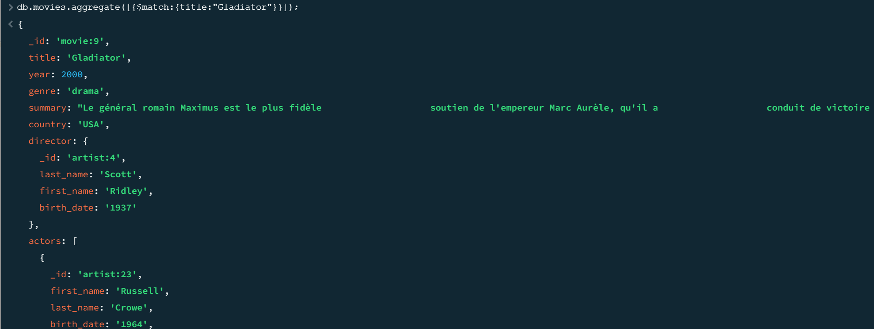

1. The distinct genre values of movies.

db.movies.distinct("genre");

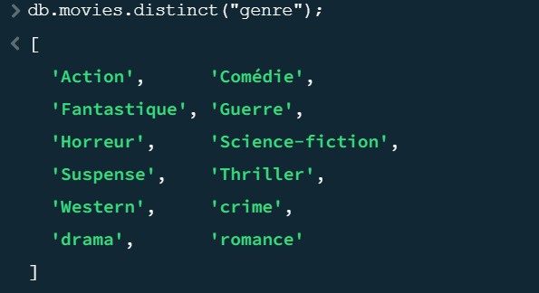

1. The movies of "crime" or "drama" genre.

db.movies.find({ $or: [ { genre: "drama" }, { genre: "crime" } ] })

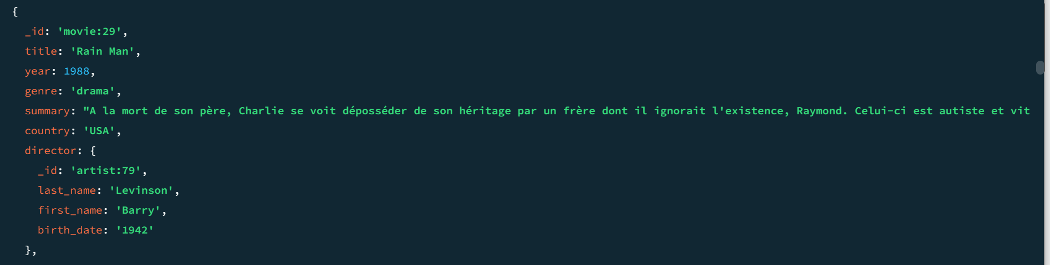

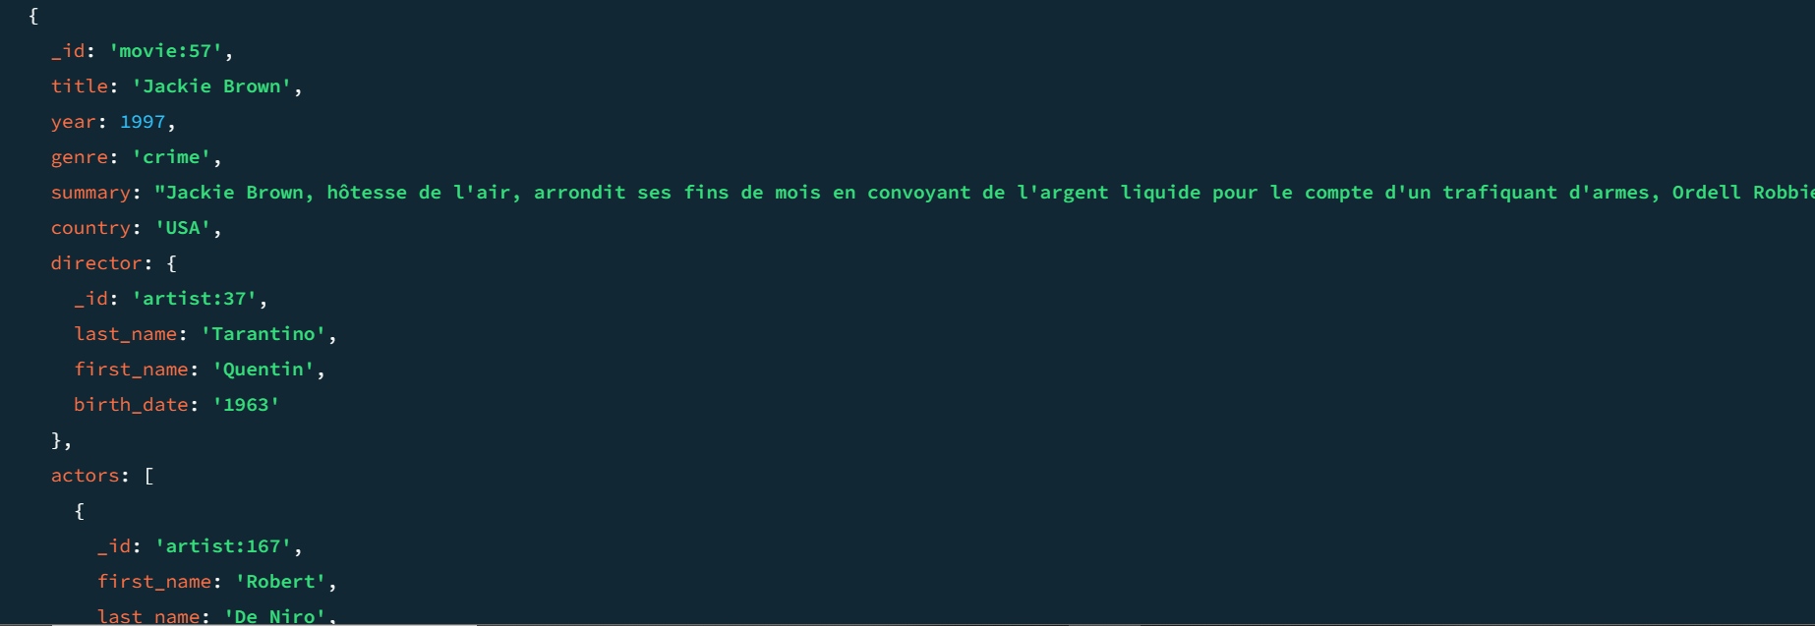

1. The list of movies directed by "Hitchcock",display only title and year andsort them by year.

db.movies.aggregate([  
 {  
 $match: { "director.last_name": "Hitchcock" }  
 },  
 {  
 $project: { _id:0,title: 1, year: 1 }  
 },  
 {  
 $sort: { year: 1 }  
 }  
])  
;

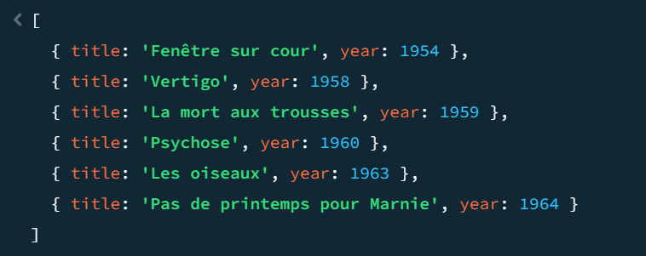

1. The list of movies where "Cotillard" played.

db.movies.find({"actors.last_name":"Cotillard"}).toArray();

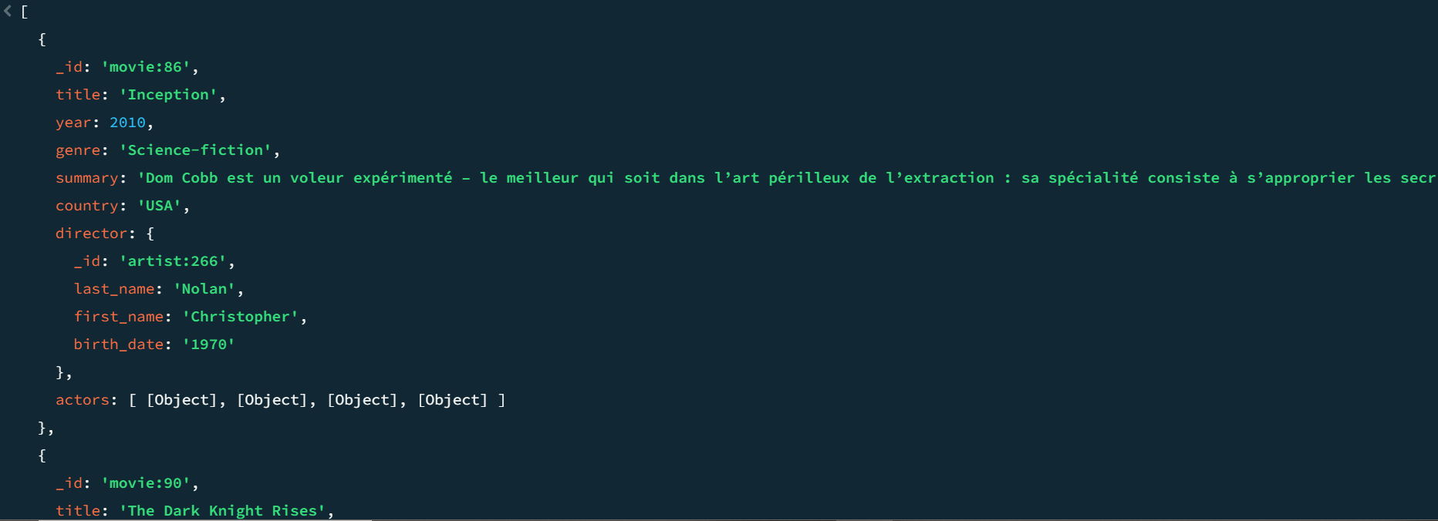

1. The movies released between 1967 and 1995.

db.movies.find({

$and: [

{ year: { $gte: 1967 } },

{ year: { $lte: 1995 } }

]

}).toArray();

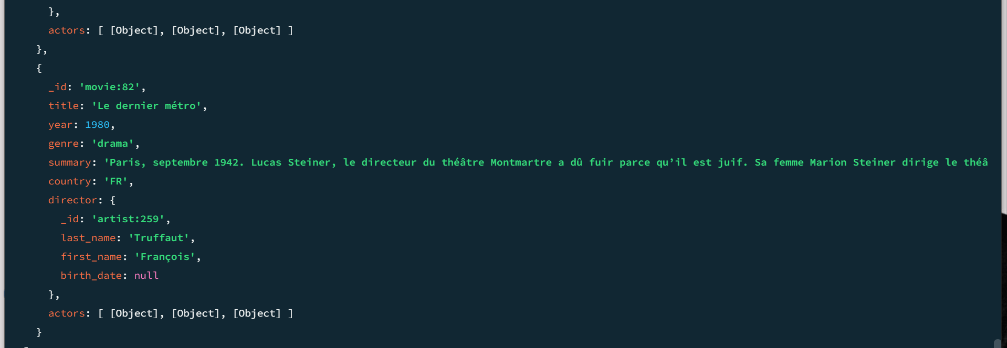

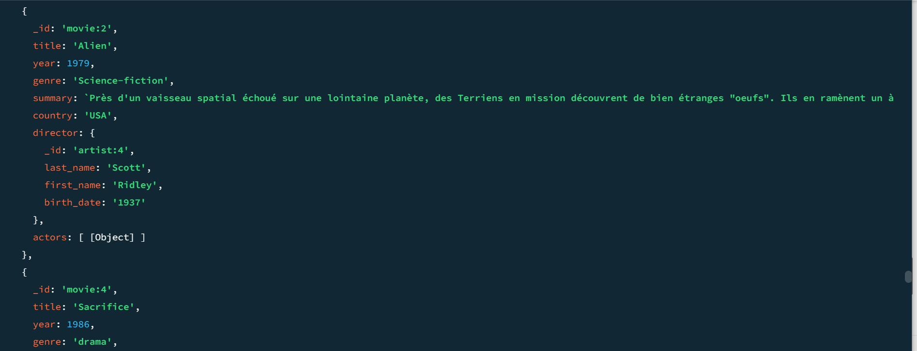

1. The list of the movies released between 1967 and 1995, by displaying only title, year, director’s last name sorted by year.

db.movies.aggregate([

{

$match: {

$and: [

{ year: { $gte: 1967 } },

{ year: { $lte: 1995 } }

]

}

},

{

$project: {

title: 1,

year: 1,

"director.last_name": 1

}

},

{

$sort: { year: 1 }

}

]).toArray();

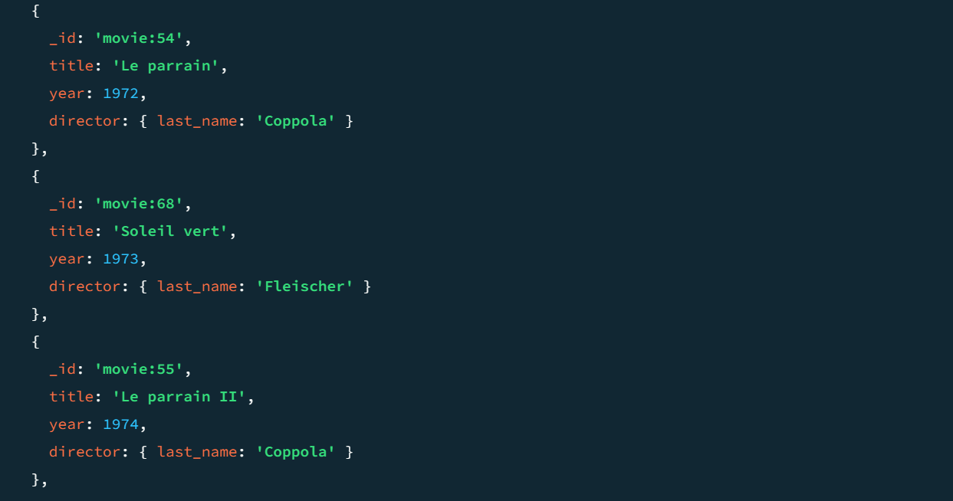

1. The number of movies by country.

db.movies.aggregate([{$group:{_id:"$country",count:{$sum:1}}}]).toArray();

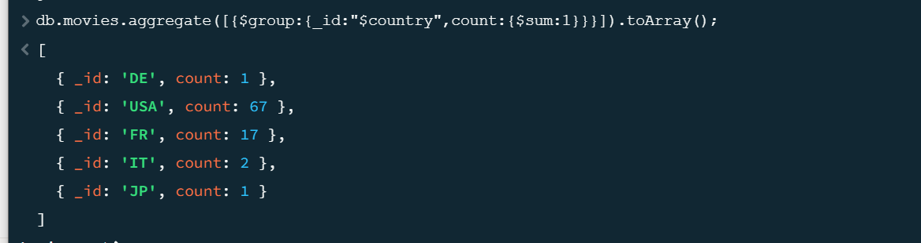

1. The number of movies by country and actor.

db.movies.aggregate([{"$group" : {_id:{"country":"$country","actor":"$actors"}, count:{$sum:1}}}]);

